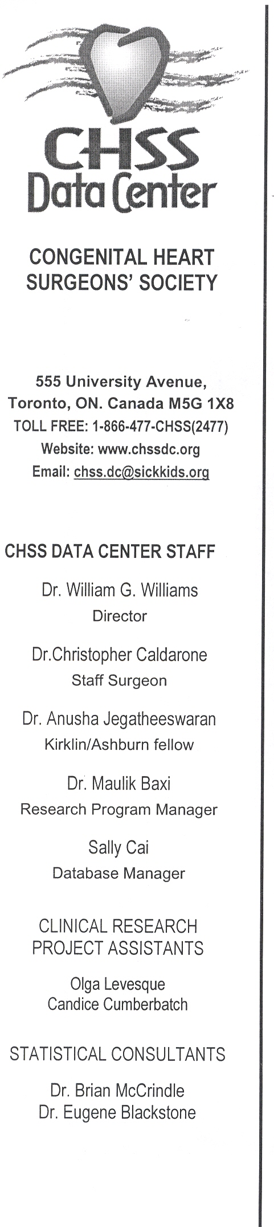

The John W. Kirklin/ David Ashburn Fellowship was created to support the efforts of a young surgeon interested in participating in the activities of the Congenital Heart Surgeons Society (CHSS) Datacenter. The fellowship is a two-year non-clinical appointment which places the Fellow at the academic center of the CHSS which is currently housed at the Hospital for Sick Children in Toronto. Fellows will be also be integral members of the Division of Cardiovascular Surgery at the Hospital for Sick Children and are expected to attend and participate in clinical conferences and clinical research meetings.
The focus of the fellowship is outcomes research, primarily of the many multi-institutional prospective cohort studies of the Congenital Heart Surgeons Society. The Fellow will become expert in database management and in all aspects of biostatistics and epidemiology. Particular emphasis is placed on the research method, presentation at national meetings, and manuscript preparation and publication.
Candidates are encouraged to complete a Postgraduate degree (Masters or Doctorate) in Biostatistics & Epidemiology or a related field through the University of Toronto. Tuition for degree completion will be provided and a surgical advisor appointed to guide thesis development. Special consideration will be given to applicants who are committed to a career in congenital heart disease.
Ideal candidates have completed some or all of their general surgical training and intend to pursue a career in congenital cardiothoracic surgery. Although not required, some prior experience with data-analysis software (Excel, SPSS, SAS, or R) is recommended.
Previous fellows have made important contributions to the field, including high profile international presentations and publication on behalf of the CHSS. The Fellows have pursued a Masters or PhD Degrees during their tenure which is facilitated by their central involvement in ongoing CHSS academic activities.
The next Fellowship will begin in July of 2010. The selection process will include the requirement for completed applications and letters of recommendation to have been received by February 15, 2009. The CHSS will endeavor to have the selection process complete by July 2009.
Summary of application procedure:
1. Interested candidates should send a letter of interest outlining their previous training, personal objectives for participating in the Fellowship, and potential sources of funding (if available). In addition, applicants should provide a current CV and 2 letters of support. The materials should be sent to the Datacenter email address (chss.dc@sickkids.ca) addressed to the attention of Dr. Chris Caldarone by February 15, 2009.
2. Exceptional candidates will be offered an interview that will take place between March – April 2009
3. Final selection will be made by June 2009.

